ATX2PCjr Assembly and Installation Notes

- Assembly -
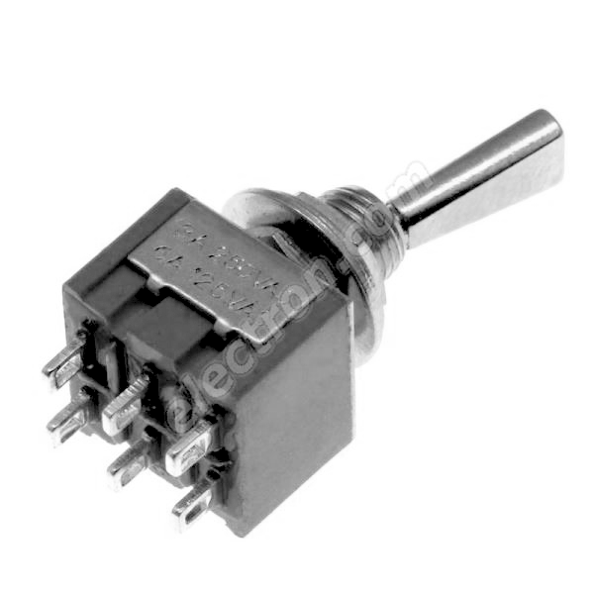
PCB Parts
Rear Panel Switches
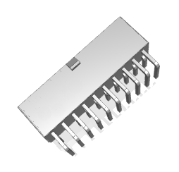
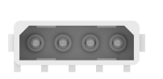
Power -
Power +
Power -

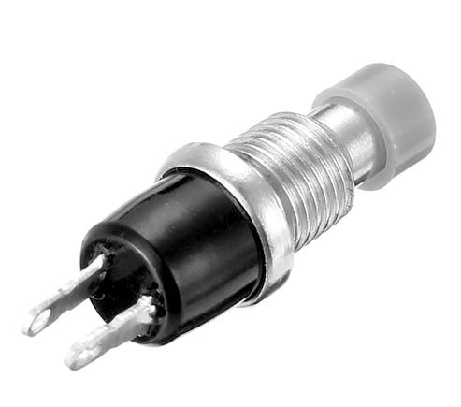
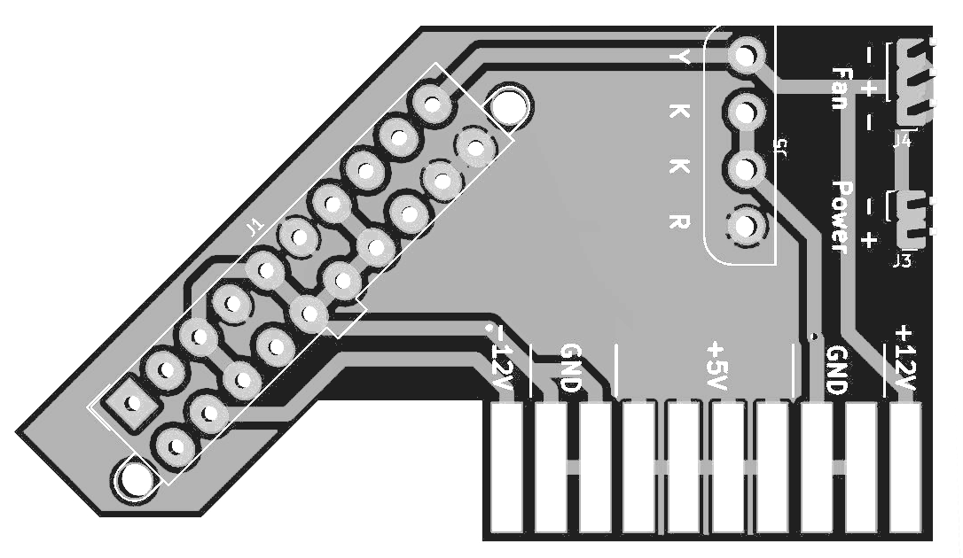
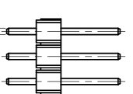

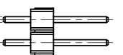
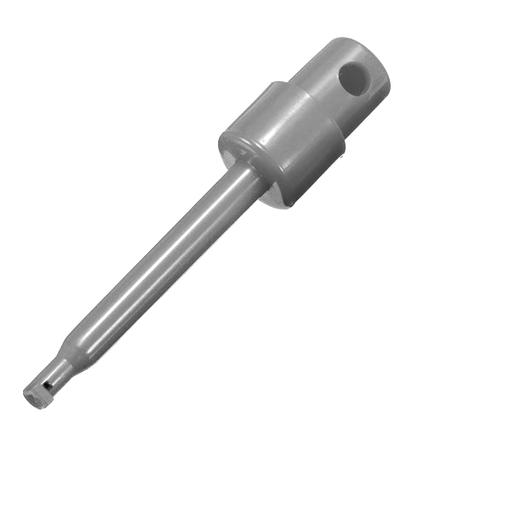

Soldering the board together is fairly straight forward. The biggest thing you need to watch for is the direction of the 4 pin connector for the floppy drive. The correct orientation is printed on the circuit board.

The toggle switch will need the cable with the connector and two wires soldered to it. The button switch will be connected to one of the wires on the toggle switch and to the hook clip. The hook’s button on the back lifts off to solder the wire on. (make sure to feed the wire through the button hole before soldering.)

- Installation -
Reset Wire Connection
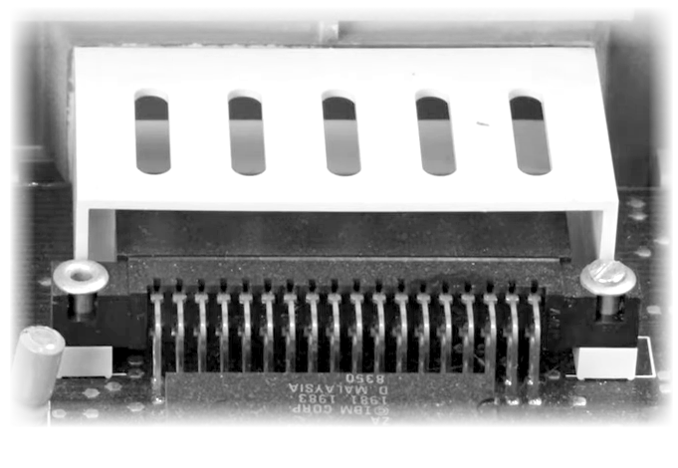
The hook clip needs to be attached to the second pin from the right on either cartridge port.

